Lab # 3a
Single-Layer Perceptron

OBJECTIVE
To understand and implement a single-layer perceptron, train it using a simple dataset, and analyze its performance in classifying linearly separable data.

THEORY

The perceptron is a fundamental building block of neural networks. It is a type of artificial neuron that uses a step function as its activation function. The perceptron algorithm is used for binary classifiers, making it an essential tool for understanding more complex neural network architectures. This lab helps students grasp the basics of neural network training, including concepts such as weights, biases, and the learning process.

Minimum Theoretical Background:

Perceptron Model:
A perceptron consists of multiple inputs, corresponding weights, a bias, and an activation function.
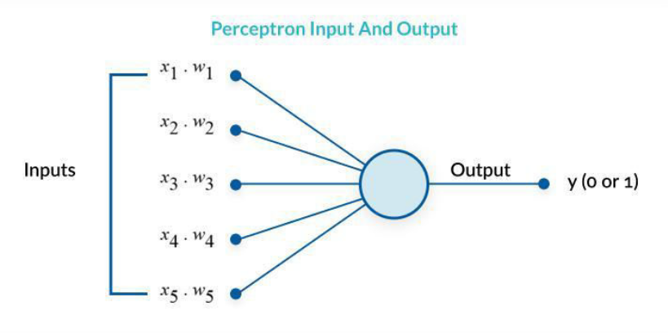
Mathematical Model:
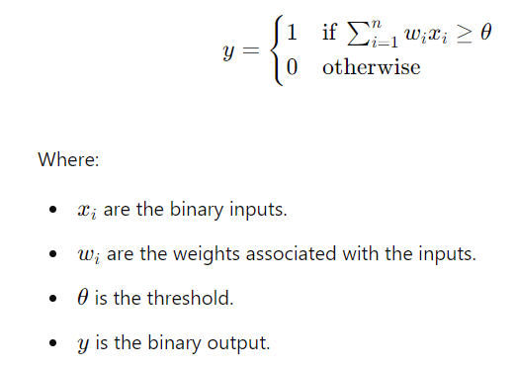

Training Algorithm:
Initialization: Initialize weights and bias to small random numbers or zeros.
Activation Function: Use a step function to determine the output.
Update Rule: Adjust weights and bias based on the error:
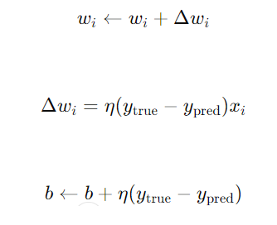
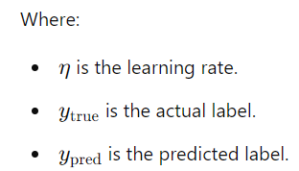

Lab Tasks:

- Python program for the single-layer perceptron on Linearly Separable Data (AND, OR, NOT, NOR, NAND)

- Attempt to train the perceptron on a non-linearly separable dataset (e.g., XOR gate) and explain why it fails.

Lab Outcomes:
This lab provides hands-on experience with the single-layer perceptron algorithm. By implementing and experimenting with the perceptron, students will understand the basics of neural network training, the importance of learning rate, and the limitations of single-layer perceptrons in solving non-linearly separable problems.

Lab # 3b
Multi-Layer Perceptron

OBJECTIVE
To understand and implement a Multi-Layer Perceptron (MLP) for classification tasks. This lab will cover building, training, and evaluating the performance of an MLP model.

THEORY

A Multi-Layer Perceptron (MLP) is a type of artificial neural network consisting of an input layer, one or more hidden layers, and an output layer. It is capable of learning non-linear relationships and is widely used in various classification and regression tasks. Understanding MLPs is essential for developing more complex neural network architectures.

Minimum Theoretical Background:

Multi-Layer Perceptron (MLP):
Structure: An MLP consists of an input layer, one or more hidden layers, and an output layer.
Activation Functions: Common functions include ReLU, Sigmoid, and Tanh for hidden layers, and Softmax for the output layer in classification tasks.
Loss Function: Measures the difference between the predicted output and the actual output. For classification, Cross-Entropy Loss is commonly used.
Optimization Algorithm: Algorithms like Gradient Descent, Adam, etc., are used to minimize the loss function.

Forward Propagation:
The process of passing inputs through the network to get the output.

Backward Propagation:
The process of updating the network's weights by calculating the gradient of the loss function with respect to each weight.

Training Process:
Initialization: Initialize weights and biases.
Forward Propagation: Calculate the output.
Loss Calculation: Compute the loss.
Backward Propagation: Update weights and biases.
Iteration: Repeat the process for a number of epochs.

Exercises:
Build the MLP Model:

Define the architecture of the MLP with input, hidden, and output layers.
Choose appropriate activation functions for each layer.

Compile and Train the Model:
Compile the model using an appropriate optimizer and loss function.
Train the model on a dataset (e.g., Iris dataset) and validate it on the validation dataset.
Plot the training and validation accuracy and loss over epochs.

Evaluate the Model:
Evaluate the model on the test dataset.
Generate a classification report and confusion matrix.

Hyperparameter Tuning:
Experiment with different hyperparameters such as learning rate, batch size, number of epochs, and number of hidden layers.
Compare the performance of the model with different hyperparameter settings.

Regularization Techniques:
Implement and compare different regularization techniques such as L2 regularization and Dropout.

Lab Tasks:

- Python program for the single-layer perceptron on Linearly Separable Data (AND, OR, NOT, NOR, NAND)

- Attempt to train the perceptron on a non-linearly separable dataset (e.g., XOR gate) and explain why it fails.

Lab Outcomes:
This lab provides hands-on experience with the single-layer perceptron algorithm. By implementing and experimenting with the perceptron, students will understand the basics of neural network training, the importance of learning rate, and the limitations of single-layer perceptrons in solving non-linearly separable problems.

